Practical: 1

Practical Title: Project Initiation, Requirement Analysis, Sitemap, Wireframe, and GitHub Setup
Problem Definition: Initiate the semester-long StudentHub portal by identifying the problem scope, user roles, key modules, navigation flow, and minimum 10 pages. Create a sitemap, low-fidelity wireframe, project folder structure, README file, and GitHub repository.

A. Theory
1. What is the URL and parts of the URL?
Answer: A URL (Uniform Resource Locator) is the address of a web page on the internet. Parts: Protocol (https://), Domain Name (example.com), Path (/page.html).
2. How does an HTML file process in a web browser?
Answer: The browser reads the HTML file, creates the page structure (DOM), applies CSS for styling, executes JavaScript if present, and then displays the web page to the user.
3. How will page navigation flow be managed among all HTML pages?
Answer: Page navigation is managed using HTML hyperlinks ( tags). Users can move between pages like Home, Login, Register, Dashboard, and other sections through these links.
4. How will GitHub commits be maintained after each practical?
Answer: After completing each practical, the changes will be committed with a clear and meaningful commit message and then pushed to the GitHub repository to maintain version history and track progress.

B. Implementation
● Identified the StudentHub Portal problem scope and user roles.
● Planned the key modules and navigation flow.
● Created a sitemap with 10+ pages.
● Designed low-fidelity wireframes.
● Organized the project folder structure.
● Created a README file and initialized a GitHub repository.
● Learned about different
commands of git Commands for git:
git status
Git add .
git commit
git pull origin main
git push origin main

C. Screenshots:
Site-Map
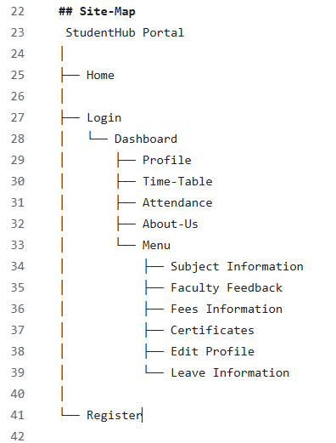

Description: This sitemap shows the navigation flow of studenthub portal.
Wire-Frames:
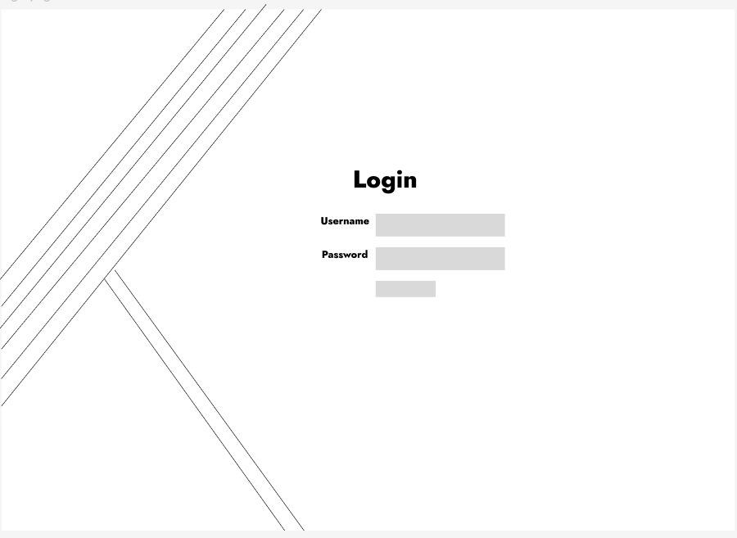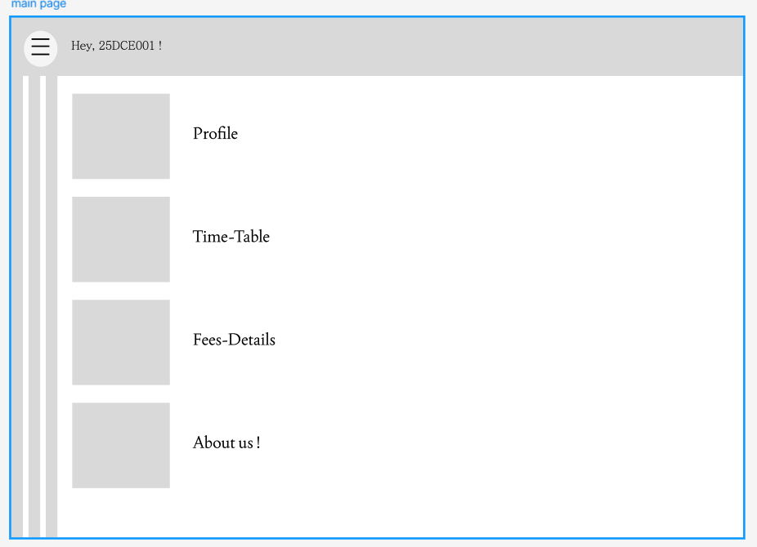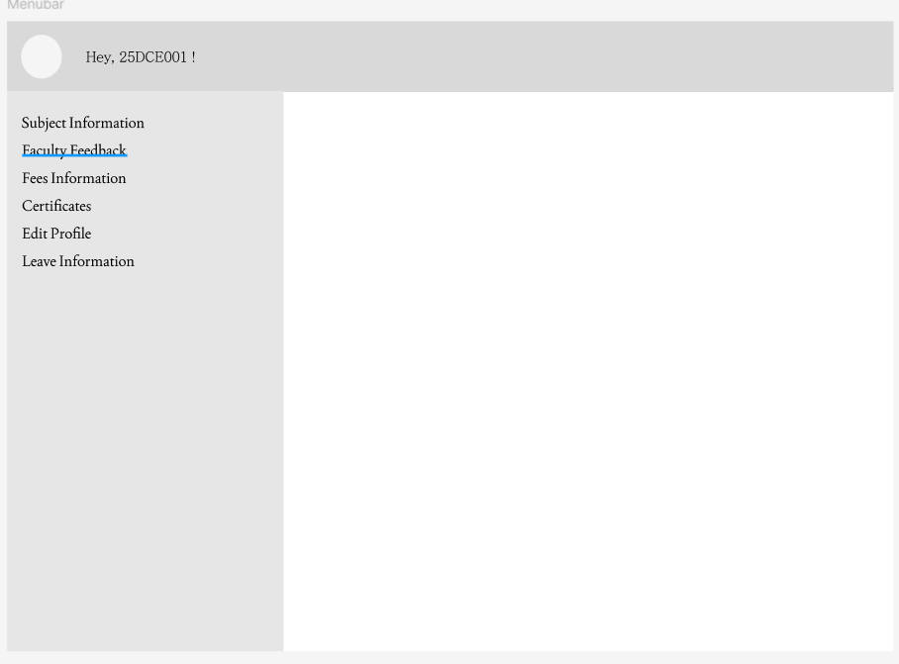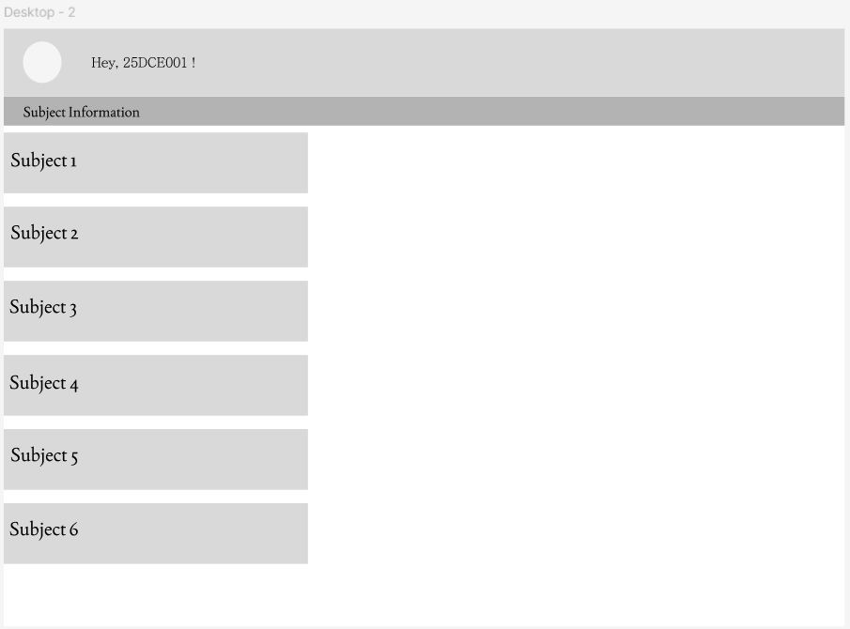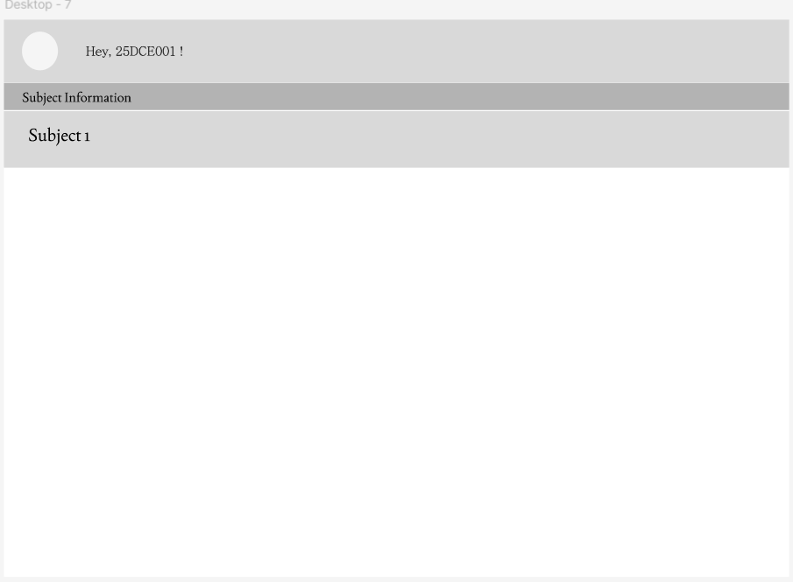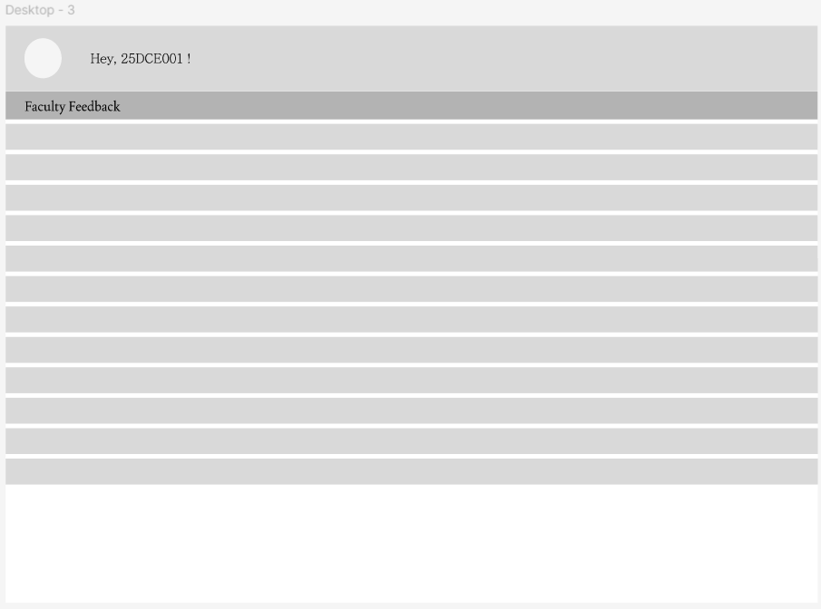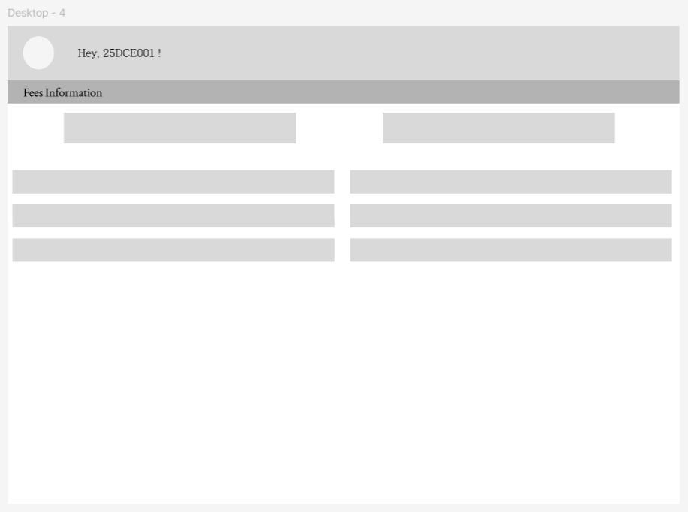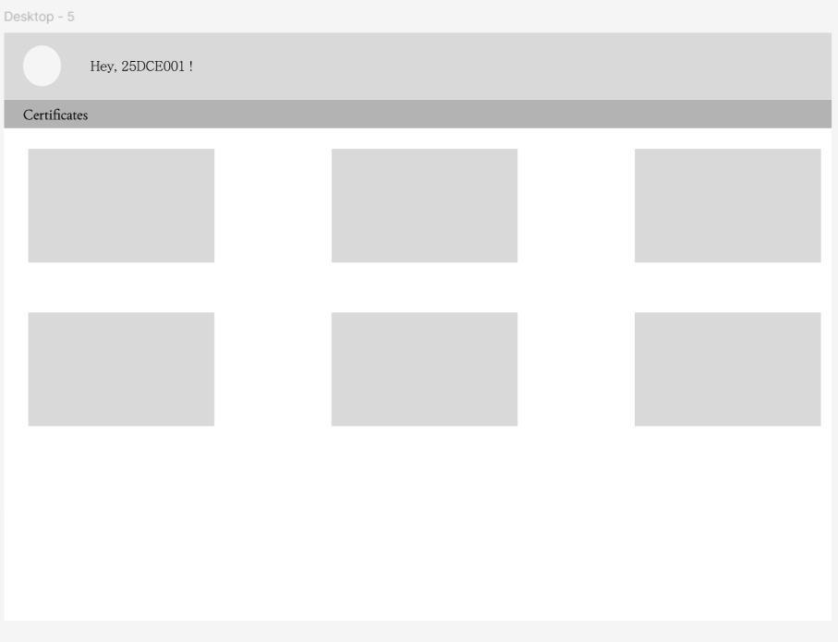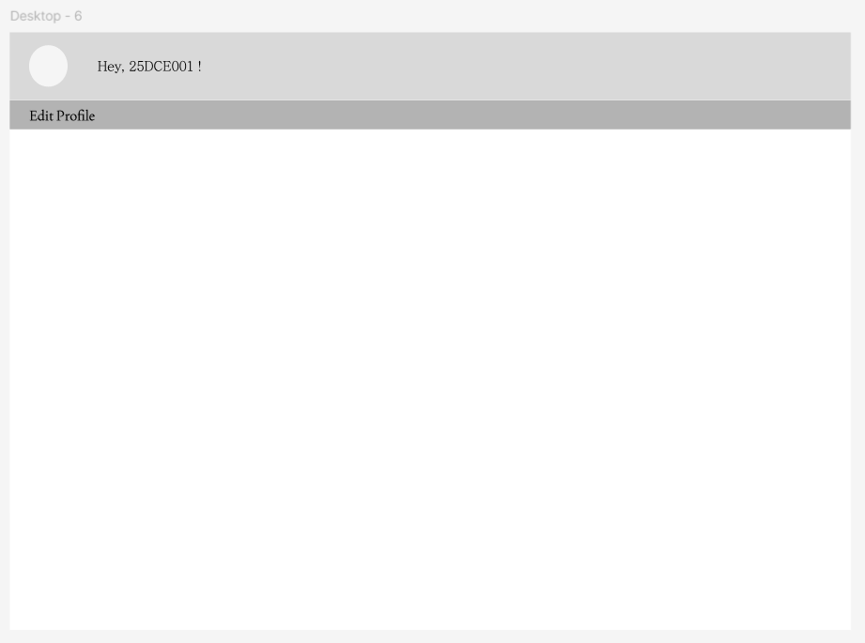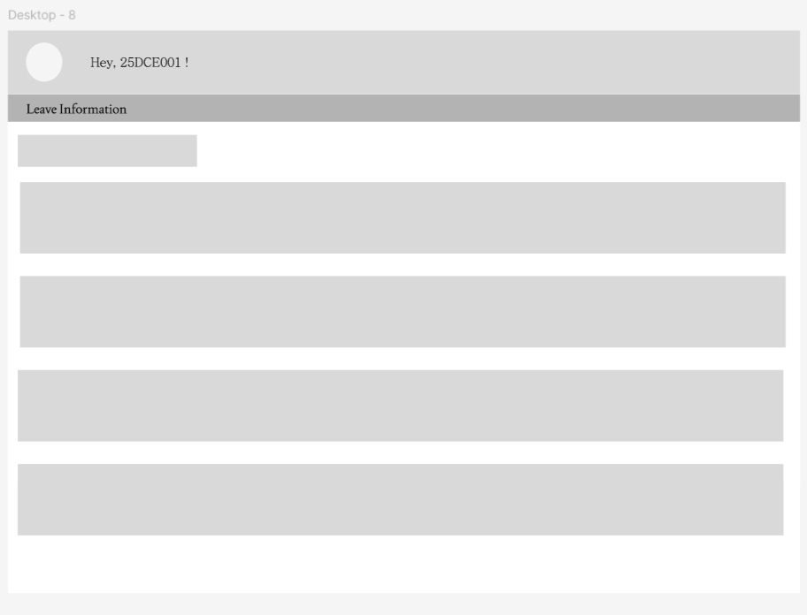

Description: This is wireframes for the studentHub portal which shows how each page will look like .

D. GitHub Repository Link:
https://github.com/margiruparel2907-collab/webdev.git
E. Challenges Faced:
I found it difficult to decide which pages and features should be included in my StudentHub Portal.

F. Learning Outcomes:
I learned how to identify and organize the essential pages and features of a website based on user requirements. I also learned how to create a clear and structured sitemap, understand the relationship between different web pages, and plan the overall navigation and user flow of the StudentHub Portal.
learned all the commands of github and git for committing changes, connecting repo to vs code editor . eg. git add ., git commit -m “”, git push, git status

Faculty Remarks:

